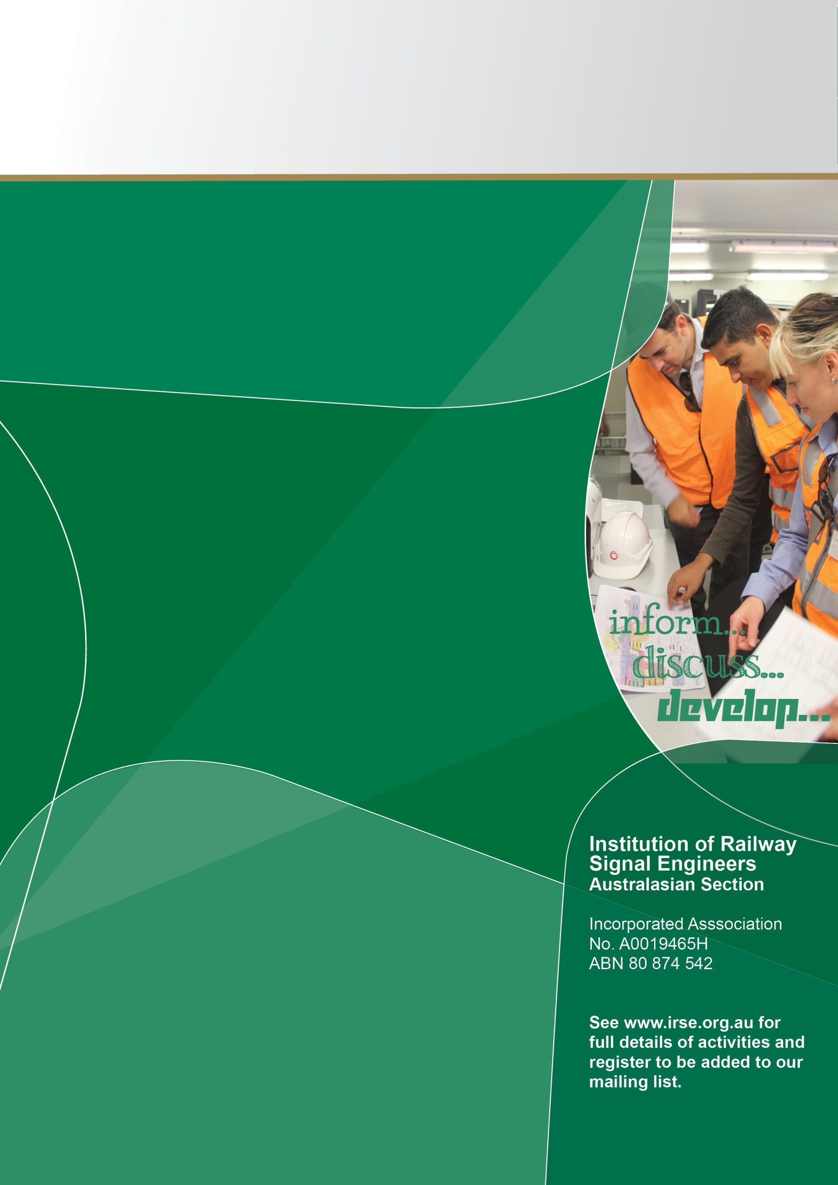


Venue:

Queensland Rail

Upper Ground Floor, 295 Ann St

Brisbane, 4000

Register Here - Eventbrite

Note that venue numbers will be limited and we reserve the right to decline registration / entry once capacity is reached.

What

17:30 – 18:30: Presentation
‘AI and Machine Learning: Why the People Still Matter’

This in-person event features a presentation aligned with the Presidential theme: Human factors in the age of automation. It will explore the critical role of human factors alongside advancing AI and machine learning technologies, emphasizing why people remain essential despite increasing automation.

Register today and join the IRSE Global President

Presenter: Roderick Muttram FIRSE | IRSE President

18:30 onwards: Networking and Refreshments

When

Tuesday 9th June 2026

Arrival – 17:00 to 17:30 for Sign-in

FREE ‘Face-to Face’ Event

Local Meeting

E-mail enquiries to: secretary@irse.org.au

Queensland

